Password Checker – Recommended Solution

Recommended Approach
For ThinkSecure, the recommended Password Checker solution is to combine zxcvbn with the Have I Been Pwned (HIBP) Pwned Passwords API.

1. zxcvbn – Password Strength Checking（）
zxcvbn will be used to estimate password strength.
Instead of only checking whether a password contains uppercase letters, numbers and symbols, zxcvbn can identify predictable patterns such as:
- common passwords;
- dictionary words;
- repeated characters;
- keyboard patterns;
- dates and years;
- common substitutions.
It can run directly in the browser, meaning the user’s password does not need to be sent to a server.

Implementation
Install:
npm install zxcvbn
Use:
import zxcvbn from "zxcvbn";

const result = zxcvbn(password);

console.log(result.score);
console.log(result.feedback);
The score ranges from:
0 = Very Weak
1 = Weak
2 = Fair
3 = Strong
4 = Very Strong
ThinkSecure can use this result to display simple educational feedback to the user.

2. Have I Been Pwned – Breach Checking
The HIBP Pwned Passwords API will check whether an example password has previously appeared in known data breaches.
The plaintext password should never be sent to HIBP.
Instead:
Password
↓
SHA-1 hash locally
↓
Take first 5 characters of hash
↓
Send only those 5 characters to HIBP
↓
Receive matching hash suffixes
↓
Compare locally
↓
Breached / Not Found
Example API request:
const response = await fetch(
`https://api.pwnedpasswords.com/range/${prefix}`
);
HIBP’s Pwned Passwords API supports this k-anonymity approach, so the complete password or complete password hash does not need to be sent to the service.

Proposed ThinkSecure Flow
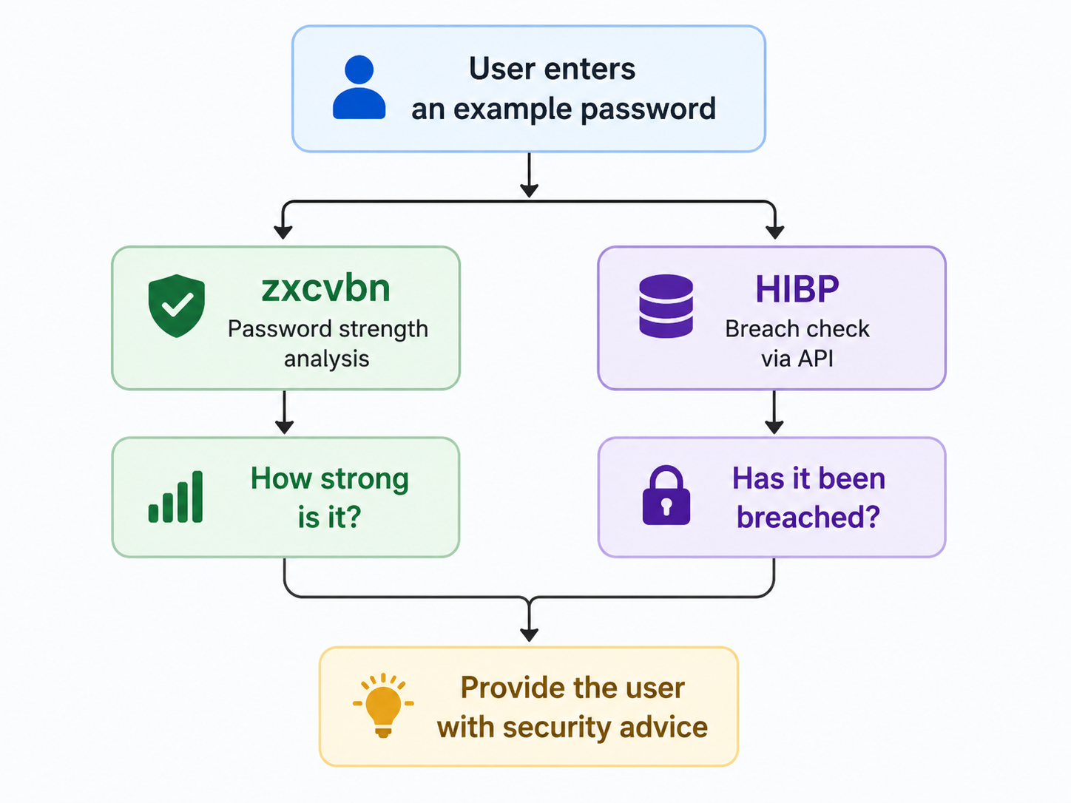For example:
Password Strength: Weak

This password contains predictable patterns.

Breach Check:
This password has appeared in known data breaches.

Recommendation:
Try using a longer and unique passphrase.

Security Requirements
Because ThinkSecure is an educational application:
- Users should be told not to enter a password they currently use.
- Password input should never be stored in the database.
- Password input should never be logged.
- zxcvbn analysis should occur locally.
- HIBP should only receive the first five characters of the SHA-1 hash.
- Password input should be cleared after the activity.

Recommendation
Use zxcvbn as the main Password Checker and HIBP as an additional breach-checking feature.
This provides ThinkSecure with both:
Password strength estimation + real breached-password checking
while avoiding the need to store or transmit plaintext passwords.

